MUNICIPAL BUDGET GENERAL EDUCATIONAL INSTITUTION
BASIC GENERAL EDUCATIONAL SCHOOL № 6
NAMED AFTER M. V. MASLIVETS
VILLAGE KRASNAYA NIVA BRYUKHOVETSKAYA REGION

THE CREATIVE PROJECT
«THE FOLK ART OF
THE KUBAN COSSACKS»

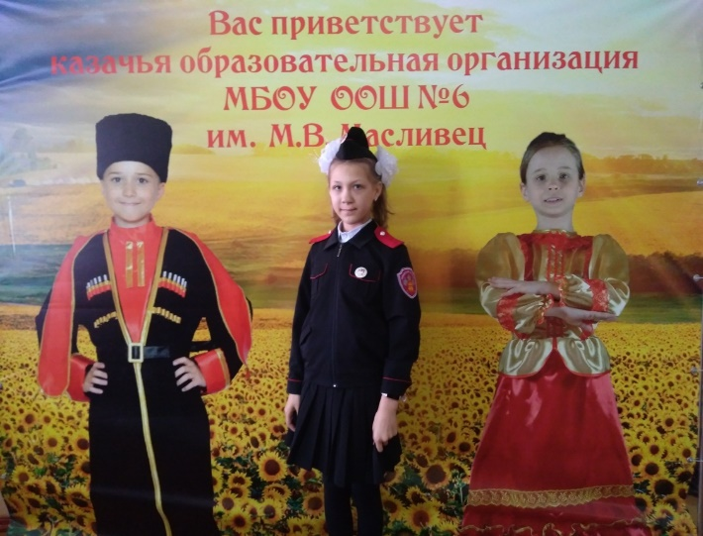

Done by Kristina Zadorozhnyaya
School № 6
named after M.V. Maslivets
Form 6 «A»
Teacher N.V. Dzhulai

v. Krasnaya Niva
2024
Contents

- Introduction 3
- The Kuban Cossack Chorus 4
- The folk art of the Kuban Cossacks 4
- The cossack women’s occupations 5
5. The cossack men’s occupations 6 6. Conclusion 7 7. Resources 8

- Introduction
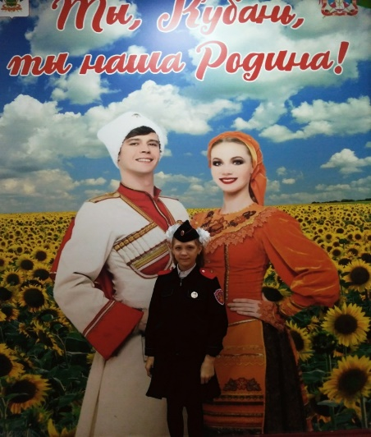
Hello, my dear friends. Let me introduce myself. My name is Kristina Zadorozhnyaya. I’m 11. I study at Cossack school 6. My school life is eventful. I have lessons, competitions, concerts, and different clubs.
Besides, I learn a lot about history, customs, and traditions of the Kuban Cossacks. It’s interesting for me. In my project I’d like to tell you about the folk art of the Kuban Cossacks. You know it is made up of ballads, folk songs, dances, traditions, customs, beliefs, proverbs, jokes, riddles and tales. Besides, it’s wonderful handicrafts. Every form is unique, and has been preserved over many centuries.
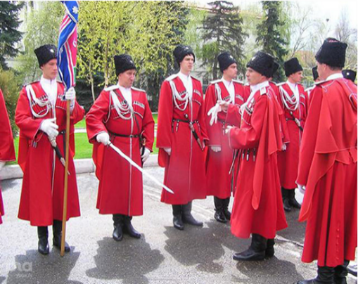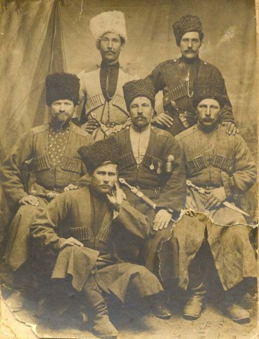

Each nation has its own customs, holidays, songs and fairy tales. They reflect the soul of the people: their way of life, love of work and land, reverence for fathers and grandfathers. These are our roots, our origins. Besides, we have one homeland - our beautiful Kuban.
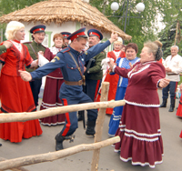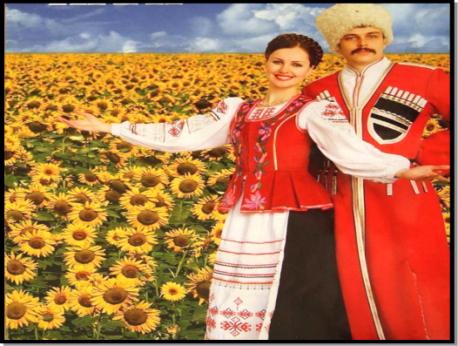

- The Kuban Cossack Chorus

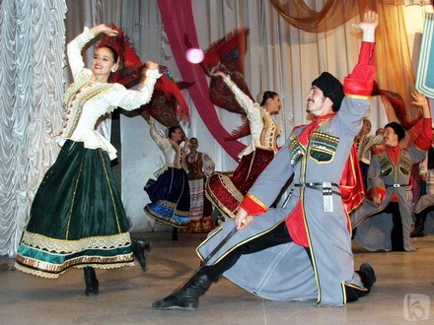
The Kuban land is famous for its rich oral folk art. The beautiful songs of the Kuban Cossacks are known not only in our country, but all over the world. The Kuban Cossack Chorus is one of the leading ensembles of Folk music in Russia. Its repertoire and performances reflect the songs, dances and folklore of the Kuban Cossacks. The modern Kuban Cossack Chorus plays different musical instruments: accordion, spoons, and balalaika.
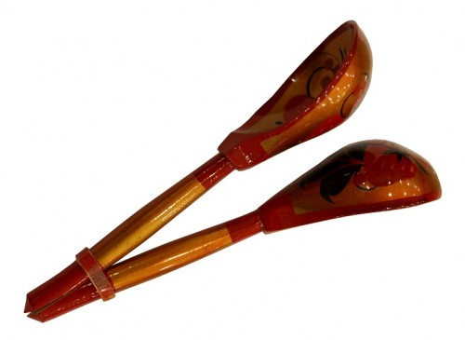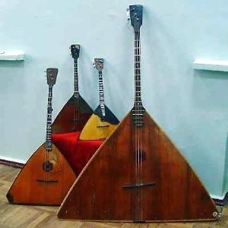

- The folk art of the Kuban cossacks
Also the Kuban Cossacks are famous for their proverbs, ditties (chastushkas) and sayings. They are about happiness and grief, about the norms of behavior in society, about heroism and love for the Motherland. National traits are also reflected in them.
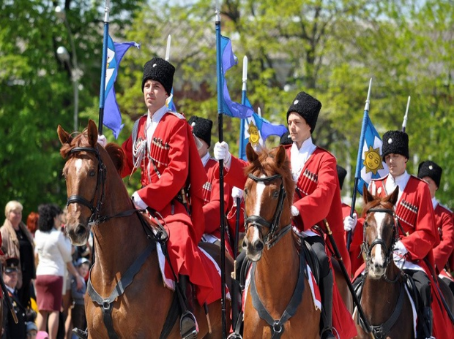

«A Cossack without faith is not a Cossack»

At the lessons of the history of the Cossacks, I learned about the decorative and applied art of our ancestors. The Cossacks were hardworking and hospitable people. Women and men in the Cossack families had their duties.
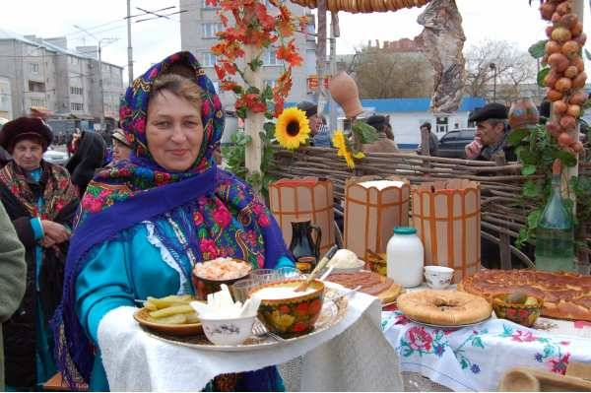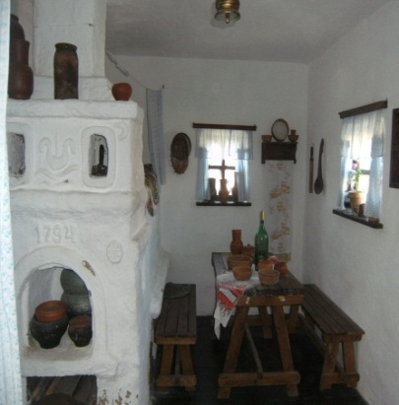
- The cossack women’s occupations
The cossack women were keen on hand embroidery and crisscross pattern. They embroidered towels, tablecloths, clothes, and pillowcases. Embroidery was the main type of folk art of the Kuban Cossacks.
Embroidered patterns not only decorated clothes and household items, but also served as amulets against evil forces. In every family women had to own various types of needlework: weaving and embroidery.
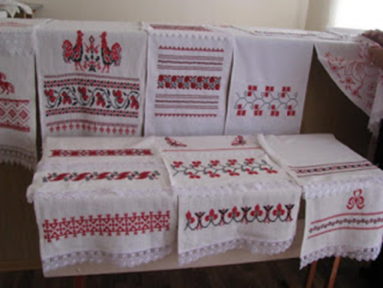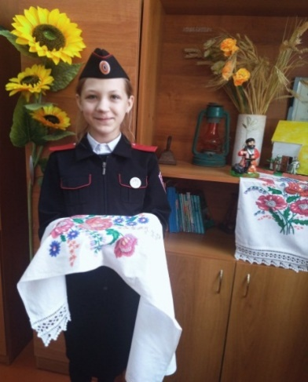
In the Kuban villages girls from 6-7 years old were taught spinning and embroidery. According to an old custom, they gathered on weekday autumn and winter evenings in some house with a good reputation, where they were engaged in needlework.
Each embroidery had its own purpose. Embroidery on shirts was located on the collar, sleeves and played the role of a talisman. Each craftswoman, using various ornaments, tried to make them individual and unique. Making patterns, they included geometric shapes: squares, stars, corners, as well as figures of birds, animals, and people. The main color of the embroidery is red, black, blue, and yellow.
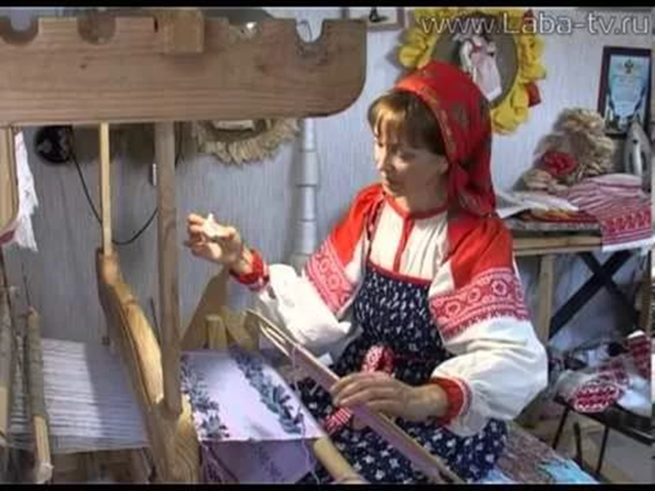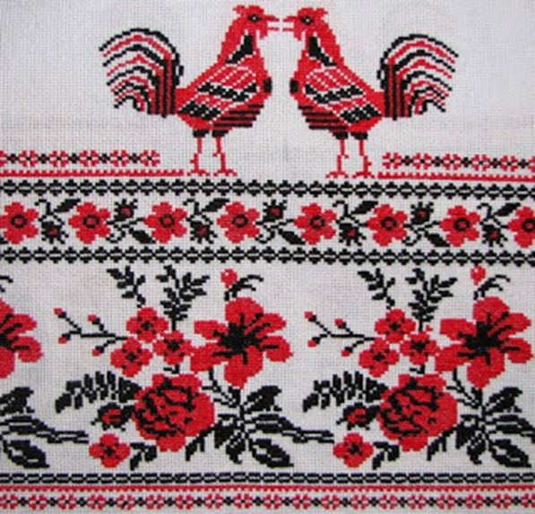
5. The cossack men’s occupations
As for Cossack men, they made wood articles, ceramics, pottery production of tableware, and clay toys. They enjoyed weaving of vines, straw, corn cob leaves (talasha).
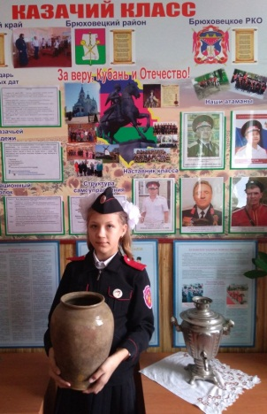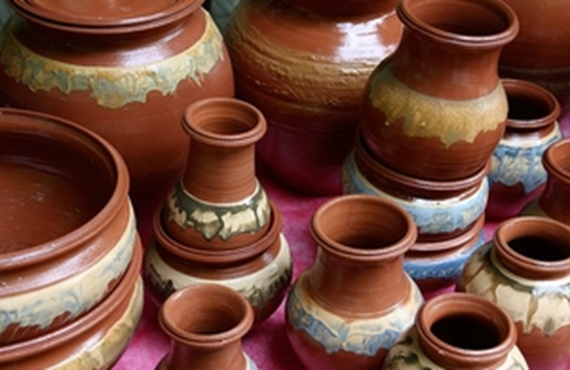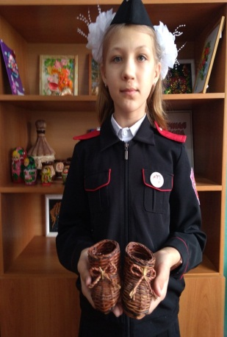
Besides, forging - blacksmithing craft was the most widespread among the Kuban Cossack men. Blacksmiths were the main masters. Everything necessary for the life was made here - horse shoes, locks, hooks, pipes, and interior items.
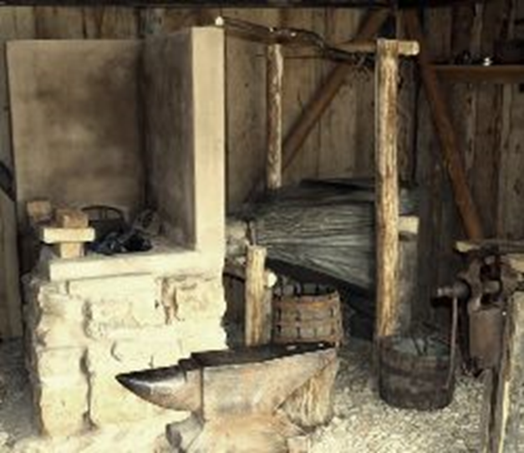
6. Conclusion
All in all, I can say that the folk art of the Kuban Cossacks is diverse. It shows the rich culture, customs and traditions of our great-grandfathers. Folk art of the Kuban Cossacks will live forever.
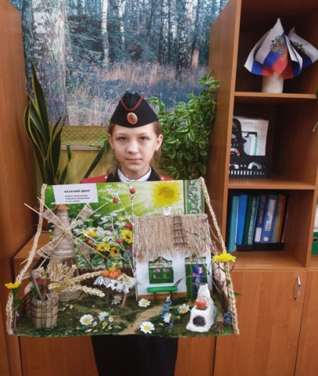

«We may wonder how the world would be if there were no folktales to listen to, no folk art to admire, no folk beliefs to ponder on, and no folk music or dances to enjoy»

7. Resources
- The history of the Kuban cossacks.
- http://www.kubanland/customs/index.html
- http://en.wikipedia.org/wiki/kuban cossack chorus

